Lab Exercise 22- Docker Image Vulnerability Scanning Using Trivy (Windows)
Objective
By the end of this lab, you will be able to:
- Install and configure Trivy on Windows
- Scan Docker images for vulnerabilities
- Interpret scan reports and take remediation actions

Prerequisites
- Windows 10/11 (with Docker Desktop installed and running)
- Internet access (Trivy downloads vulnerability databases)
- Basic familiarity with Docker CLI commands

Step 1: Verify Docker Setup
Before using Trivy, make sure Docker is working correctly.
docker --version
docker run hello-world
Expected Output:
Docker runs successfully and displays the “Hello from Docker!” message.
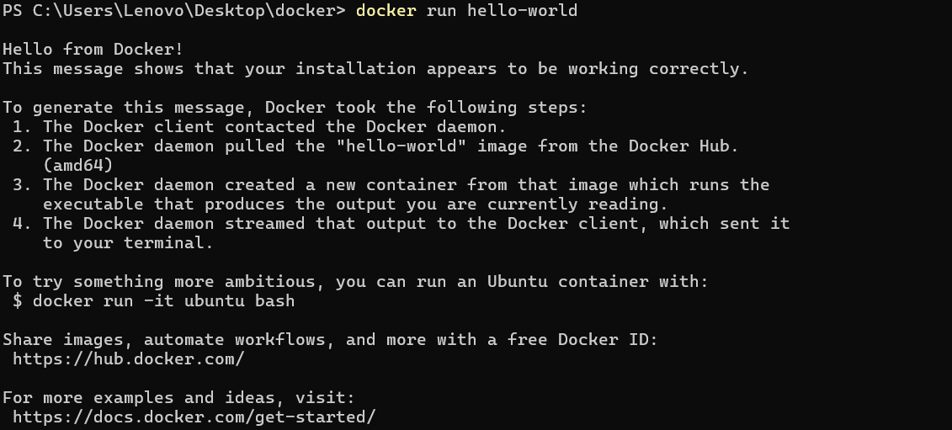

Step 2: Install Trivy on Windows
Manual Installation
- Go to the official GitHub releases page:
https://github.com/aquasecurity/trivy/releases
- Download the Windows ZIP file (trivy_x.x.x_windows_amd64.zip)
- Extract it (e.g., to C:\trivy)
- Add that folder to your System PATH environment variable
Verify Installation
Open PowerShell and run:
trivy --version
Expected Output: Trivy version and build information.
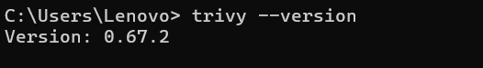

Step 3: Pull a Docker Image
Let’s pull an image that we’ll scan:
docker pull nginx:latest
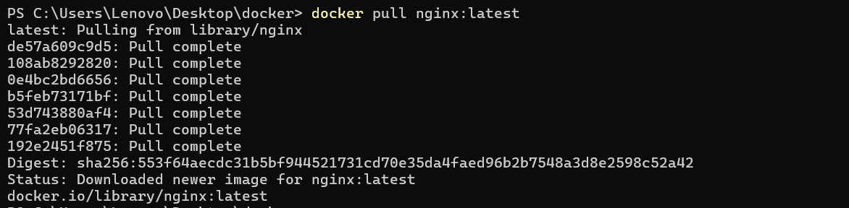
Check it’s downloaded:
docker images
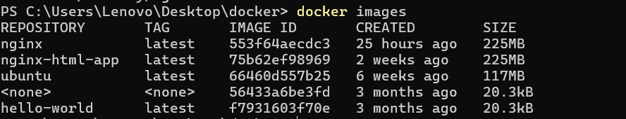

Step 4: Scan Docker Image with Trivy
Now, run a vulnerability scan on the image:
trivy image nginx:latest
Explanation:
Trivy will:
- Fetch the latest vulnerability database
- Analyze all OS packages and libraries inside the image
- Display severity levels (LOW, MEDIUM, HIGH, CRITICAL)
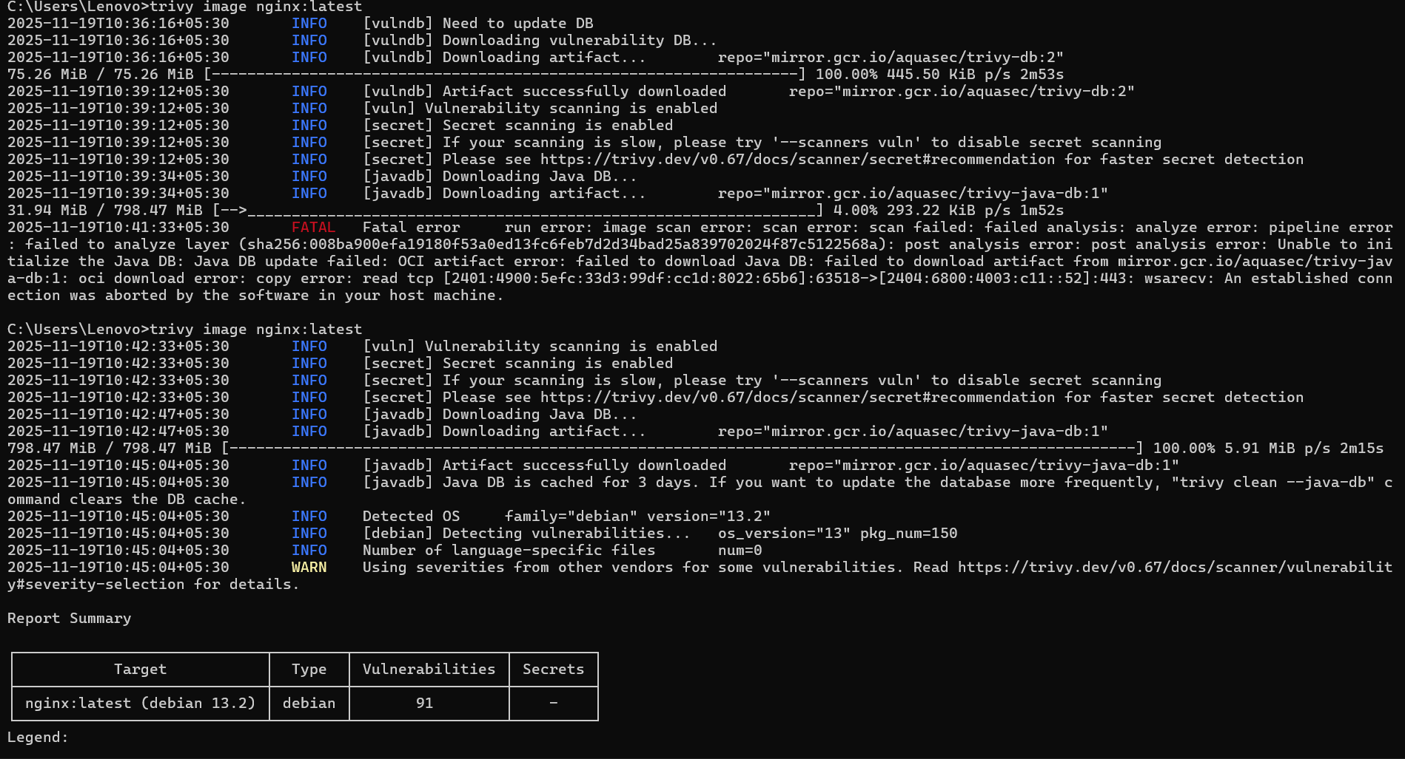
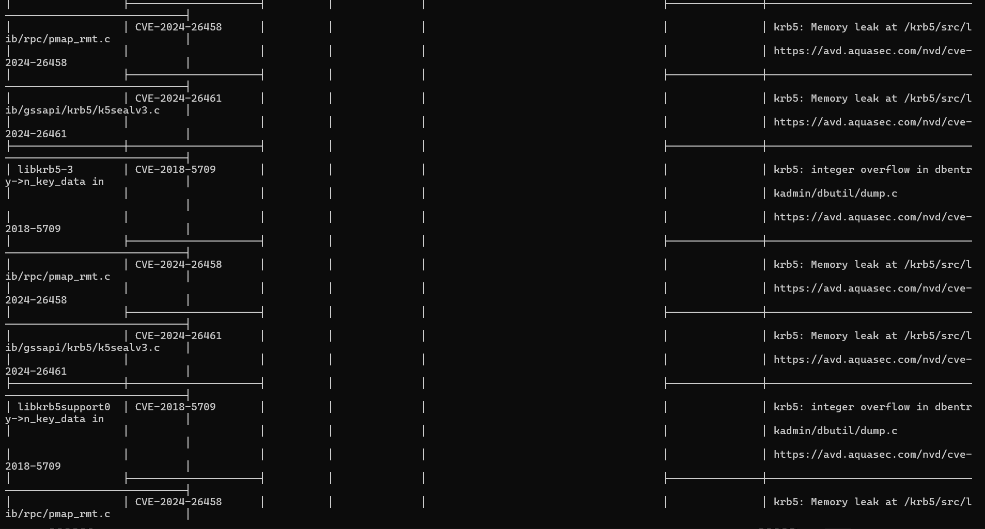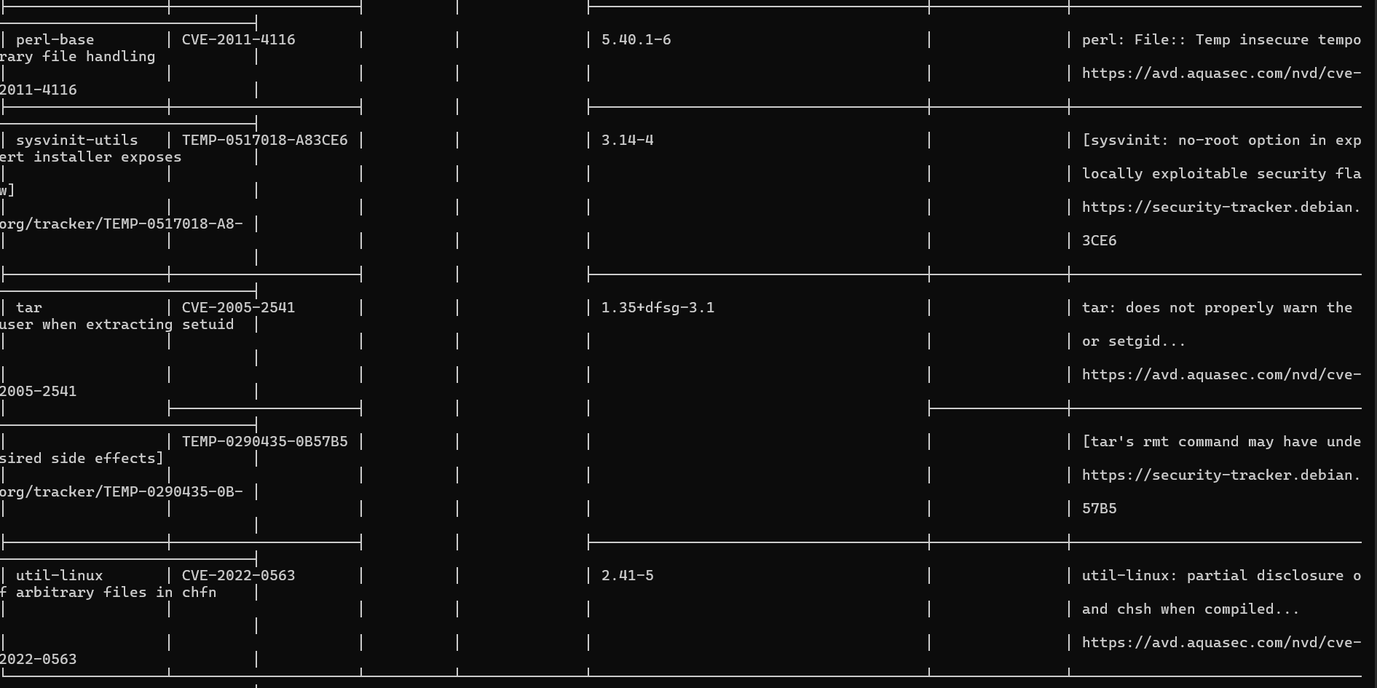

Sample Output
nginx:latest (debian 12.2)
==================================
Total: 12 (LOW: 2, MEDIUM: 4, HIGH: 5, CRITICAL: 1)
┌──────────────┬────────────────────────────┬────────┬──────────────────┬──────────────┐
│ PACKAGE │ VULNERABILITY ID │ SEVERITY │ INSTALLED VERSION │ FIXED VERSION │
├──────────────┼────────────────────────────┼────────┼──────────────────┼──────────────┤
│ openssl │ CVE-2023-0464 │ HIGH │ 3.0.9-1 │ 3.0.9-2 │
│ zlib │ CVE-2022-37434 │ MEDIUM │ 1.2.11-5 │ 1.2.12 │
└──────────────┴────────────────────────────┴────────┴──────────────────┴──────────────┘

Step 5: Save Report to a File
You can export the results in different formats.
Save as a text file:
trivy image nginx:latest > nginx_scan.txt
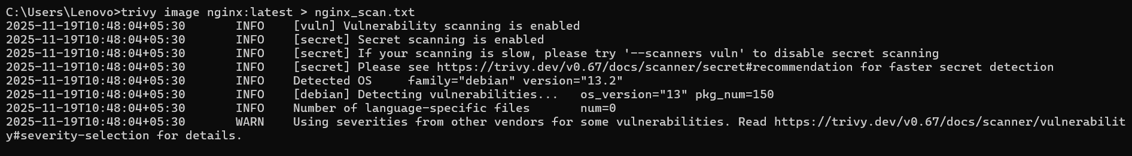
Save as a JSON report:
trivy image --format json -o nginx_scan.json nginx:latest
Tip: JSON format is useful for automation or CI/CD integration.

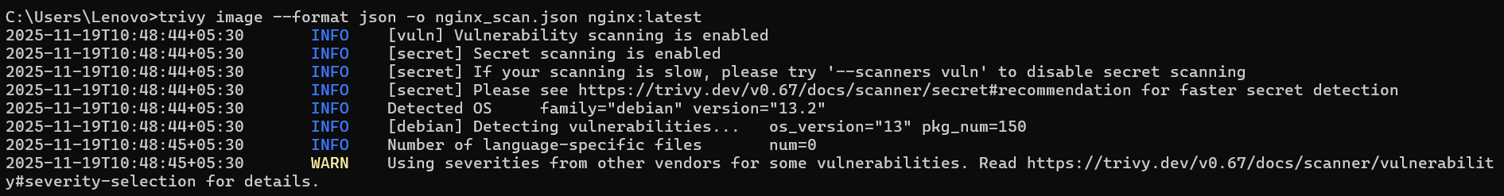

Step 6: Scan a Local Image
If you’ve built your own Docker image:
docker build -t myapp:1.0 .
trivy image myapp:1.0
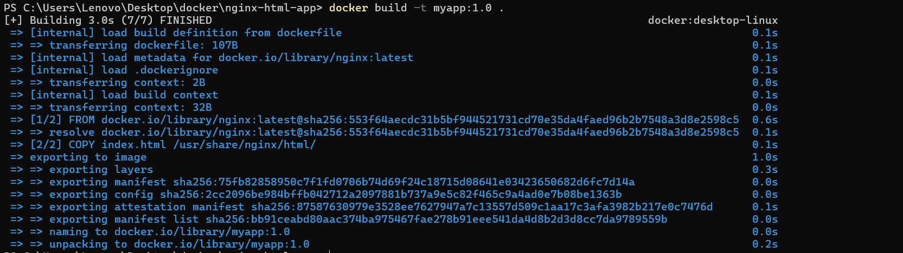

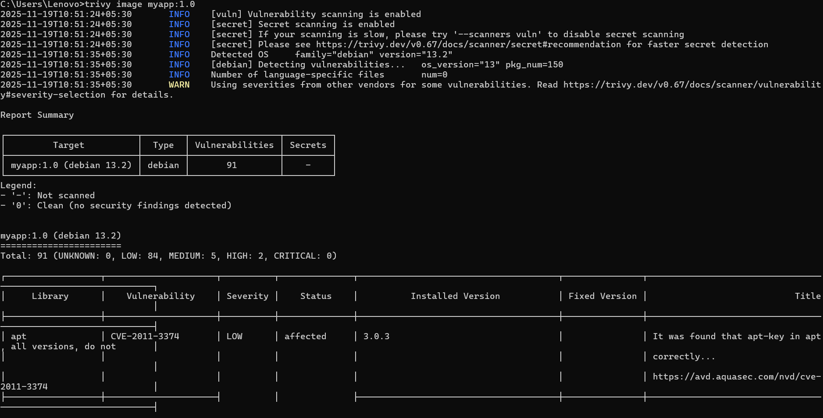
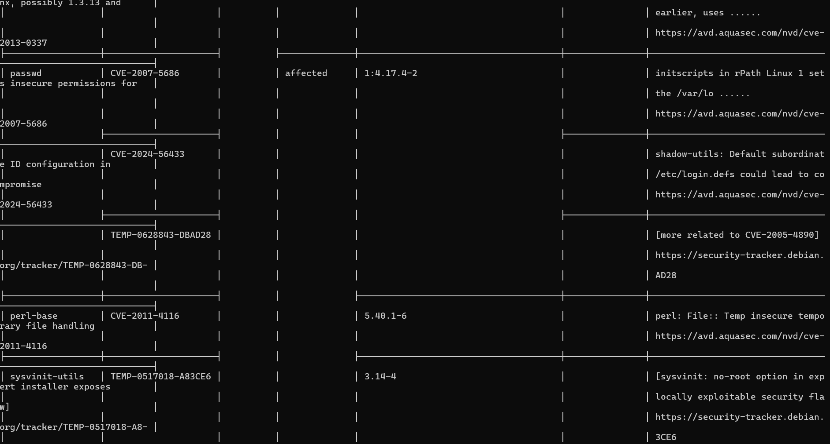

Step 7: Update Vulnerability Database
Keep Trivy’s database up-to-date:
trivy image --download-db-only

Step 8: Clean Up
Remove images (optional):
docker rmi nginx:latest

